**QSMART – POWER SUPPLY REPLACEMENT**

**PROCEDURE**

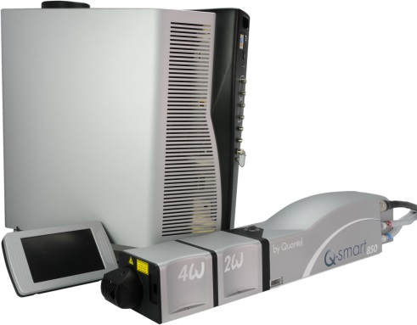

**Toolkit:**

Allen keys

**System** : QSMART

|  |  |  |  |  |  |  |  |  |  |  |
| --- | --- | --- | --- | --- | --- | --- | --- | --- | --- | --- |
| |  |  | | --- | --- | | **SM010358** | **Q-SMART POWER SUPPLY** | | | | | |  |  |  |  |
|  |  |  |  |
|  |  |  |  |

**Purpose**: This document details how to change the power supply

|  |  |  |
| --- | --- | --- |
| Revision | date | modification |
|  |  |  |
|  |  |  |
|  |  |  |
|  |  |  |

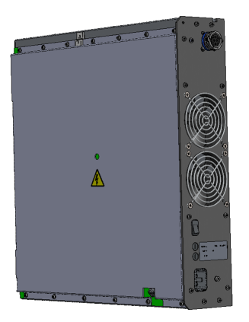

# DISASSEMBLY

* Unplug the system and disconnect all cables

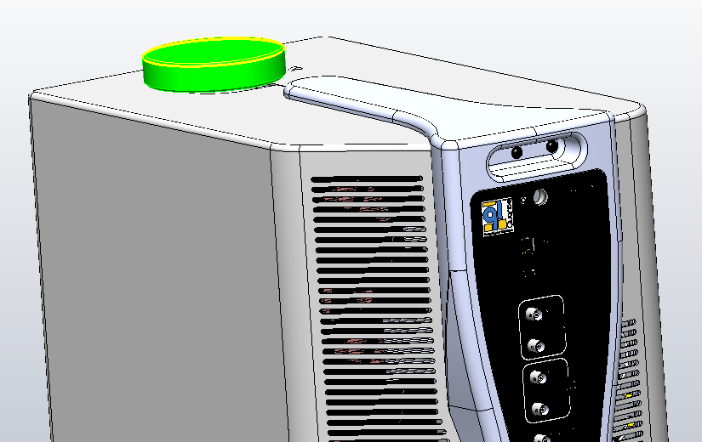

* Remove the CG cap

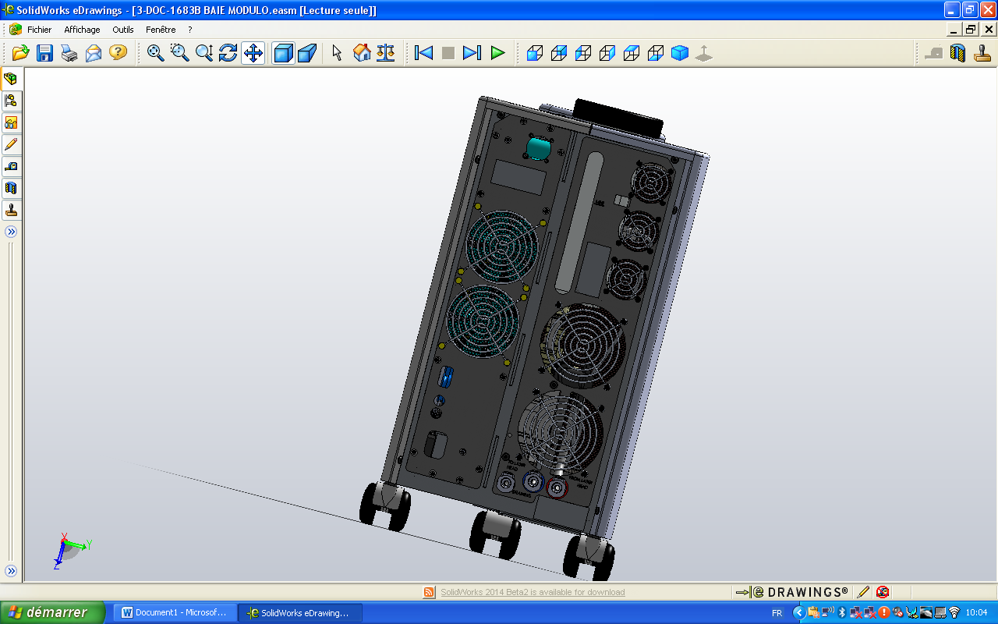

3/E13/0600

* Remove the 4 screws 3/E13/0600 (Rear panel)

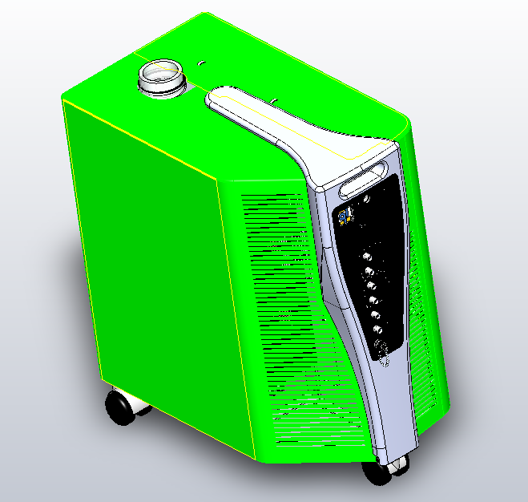

3/E13/0600

* Remove the 4 screws 3/E13/0600 (front). Remove the two side panels

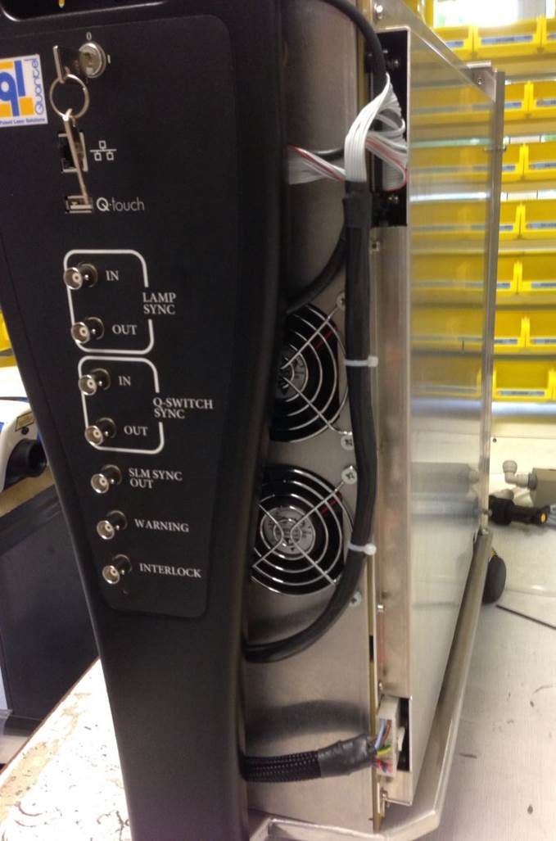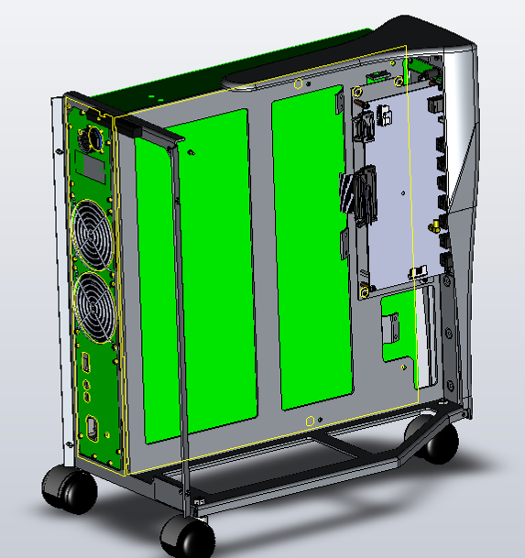

* Remove the 3 screws BHC 4x12 (3/E13/0600) from the PB

3/E13/0600

* Disconnect the cable kit 4/300/1070 from the PB card.

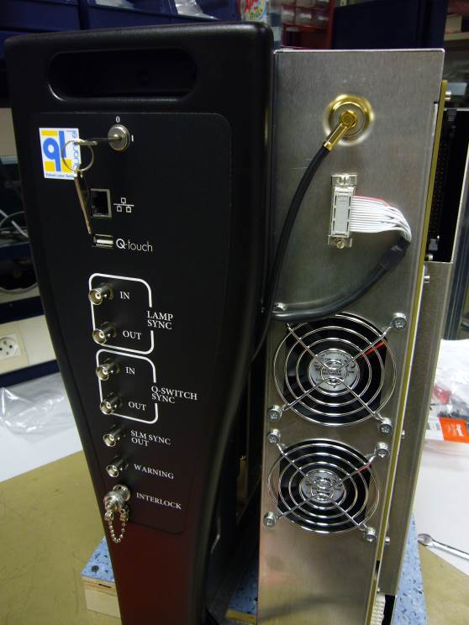

Remove the two connectors.

Remove the power supply

# INTEGRATION OF THE POWER SUPPLY

|  |  |  |
| --- | --- | --- |
| 3.00 | 3/E13/0600 | BLACK BHC 4x12 SCREW |
| 2.00 | 4/CBL/0005 | SMALL TYRAP |



* Set up the two connectors as pictured



Put back in place the PB card into the ICE

Connect the cable kit 4/300/1070 to the PB card like shown.

Attach the cables with tyraps



Fasten the power supply with 3 BHC 4x12 (3/E13/0600)

3/E13/0600

# COVERING

|  |  |  |
| --- | --- | --- |
| 8.00 | 3/E13/0600 | VIS BHC 4x12 NOIRE |

Implement both side panel and fasten with 8 BHC Black 4x12 (3/E13/0600) screws



3/E13/0600



3/E13/0600

CAUTION: Leave a space between two covers

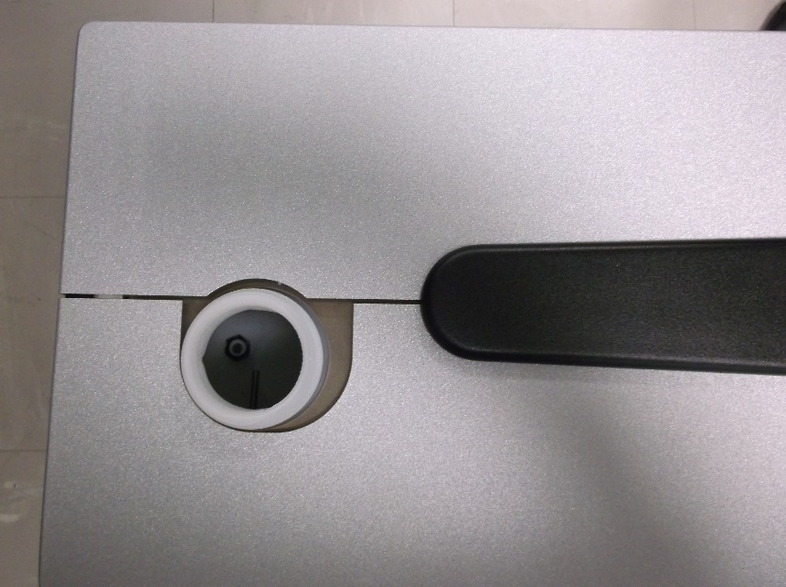



Put back in place the CG cap